**CarCortex**

**A PROJECT REPORT**

For

## MiniProject-I(ID201B)

## Session (2024-25)

## Submitted by

## KUNAL SINGH

#### 2024101161001109

**KUMAR KASHYAP**

#### 202410116100106

**KUNAL MALHOTRA**

#### 202410116100107

**LAVISH NEHRA**

#### 202410116100111

## Submitted in partial fulfilment of the Requirements for the Degree of

**MASTER OF COMPUTER APPLICATION**

## Under the Supervision of

## Ms. Shruti Aggarwal

## Assistant Professor

## 

## Submitted to

Department Of Computer Application

KIET Group of Institutions,

Ghaziabad, Uttar Pradesh-201206

# CERTIFICATE

# Certified that Kunal Singh 202410116100109, Kumar Kashyap 202410116100106, Kunal Malhotra 202410116100107, Lavish Nehra 202410116100111 have carried out the project work having “CarCortex” (Mini Project-I, ID201B) for Master of Computer Application from Dr.A.P.J. Abdul Kalam Technical University (AKTU) (formerly UPTU), Lucknow under my supervision. The project report embodies original work, and studies are carried out by the student himself/herself and the contents of the project report do not form the basis for the award of any other degree to the candidate or to anybody else from this or any other University/Institution.

#### Ms. Shruti Aggarwal Dr. Akash Rajak

#### Assistant Professor Dean

#### Department of Computer Applications Department of Computer Applications KIET Group of Institutions, Ghaziabad KIET Group of Institutions, Ghaziabad

**ABSTRACT**

CarCortex is an innovative web-based platform designed to assist vehicle owners in estimating the resale value of their cars before selling them online. The platform leverages market data, vehicle specifications, and AI-driven pricing algorithms to provide users with accurate and fair price estimates.

The primary objective of CarCortex is to eliminate uncertainty in the car-selling process by offering transparent and data-driven price evaluations. Users can enter details such as the car's make, model, year of manufacture, mileage, condition, and other relevant factors to receive a precise price estimate.

By integrating real-time market trends and leveraging machine learning models, CarCortex ensures that users receive competitive valuations based on current industry standards. This platform aims to enhance the selling experience by empowering users with the right pricing insights, thereby helping them make informed decisions when listing their vehicles for sale online.

CarCortex is a step toward digitalizing and simplifying the used car market, making it more accessible and efficient for both individual sellers and potential buyers.

**ACKNOWLEDGEMENTS**

##### Success in life is never attained single-handedly. My deepest gratitude goes to my project supervisor, **Ms. Divya Singhal** for her guidance, help, and encouragement through out my project work. Their enlightening ideas, comments, and suggestions.

##### Words are not enough to express my gratitude to Dr. Arun Kumar Tripathi, Professor and Dean, Department of Computer Applications, for his insightful comments and administrative help on various occasions.

##### Fortunately, I have many understanding friends, who have helped me a lot on many critical conditions.

##### Finally, my sincere thanks go to my family members and all those who have directly and indirectly provided me with moral support and other kind of help. Without their support, completion of this work would not have been possible in time. They keep my life filled with enjoyment and happiness.

#### Kunal Singh

#### Kumar Kashyap

#### Kunal Malhotra

#### Lavish Nehra

**TABLE OF CONTENTS**

1. **Introduction**  
   1.1 Project Description  
   1.2 Scope  
   1.3 Objectives  
   1.4 Advantages  
   1.5 Disadvantages
2. **Methodology and Feasibility**  
   2.1 Methodology  
   2.2 Feasibility
3. **SOFTWARE REQUIREMENT SPECIFICATION**

3.1 Product Perspective

3.2 System Interfaces

3.3 System Specifications

3.4 H/W Requirement

* 1. S/W Requirement

1. **Database Design**  
   4.1 Data Flow Diagram (DFD)

4.1.1 Context Level Diagram

4.1.2 DFD Level – 1

4.2 Use Case Diagram

4.3 ER Diagram

1. **Design (Output)**  
   5.1 User Interface
2. **Conclusion**
3. **Bibliography**

## ****INTRODUCTION****

### ****1.1 Project Description****

CarCortex is a web-based platform designed to assist vehicle owners in estimating the resale value of their cars before selling them online. The platform utilizes advanced algorithms, real-time market data, and artificial intelligence to provide accurate and fair price assessments based on various factors, including the car’s make, model, year of manufacture, mileage, condition, and additional features. By offering a data-driven valuation approach, CarCortex eliminates the uncertainty often associated with pricing a used vehicle, empowering sellers with reliable and competitive price estimates.

The platform is built with a user-friendly interface that allows individuals to input their car details seamlessly and receive an instant estimated selling price. The valuation model considers historical sales data, depreciation trends, and current market demand to ensure precision in pricing. Additionally, CarCortex integrates real-time market trends and comparisons with similar listings, helping users understand their car’s market position and make informed decisions when listing their vehicles online.

To ensure efficiency and accuracy, CarCortex leverages machine learning techniques that continuously update pricing predictions based on evolving market conditions. The platform aims to benefit not only individual car owners but also dealerships and automotive businesses that require reliable valuation insights. By simplifying the used car pricing process, CarCortex enhances transparency and trust in online car sales, making it easier for sellers to set competitive prices and attract potential buyers.

### ****1.2 Scope****

CarCortex aims to revolutionize the way vehicle owners determine the resale value of their cars by providing an AI-powered price estimation tool. The platform is designed to cater to individual sellers, car dealerships, and automotive businesses, offering a seamless and efficient way to assess the fair market price of used vehicles.

The project’s scope includes the development of a web-based application that allows users to input essential car details such as make, model, year of manufacture, mileage, and condition to receive an instant price estimate. By leveraging machine learning algorithms and real-time market data, the platform ensures accuracy and transparency in pricing, reducing the uncertainty faced by sellers.

CarCortex will continuously update its pricing model based on historical sales trends, depreciation patterns, and demand fluctuations in the used car market. The system will also provide comparative insights, enabling users to see how their car’s value aligns with similar listings. Additionally, the platform may integrate with third-party car marketplaces, allowing sellers to list their vehicles directly after receiving a price estimate.

The project has the potential to expand beyond basic price estimation by incorporating additional features such as vehicle history checks, buyer recommendations, and predictive analytics for future price trends. Furthermore, scalability options include developing a mobile application, integrating with car dealerships, and offering API services for businesses that require automated vehicle valuation.

By streamlining the car-selling process and ensuring fair pricing, CarCortex will enhance the overall efficiency and trustworthiness of online vehicle transactions, making it an essential tool for both individuals and businesses in the automotive sector.

### ****Objectives****

* **Provide Accurate Vehicle Valuation** – Offer reliable and data-driven price estimates for used cars based on market trends, historical sales data, and vehicle-specific factors.
* **Eliminate Pricing Uncertainty** – Help car owners determine a fair and competitive selling price, reducing guesswork and improving transparency in the used car market.
* **Leverage AI and Machine Learning** – Utilize advanced algorithms to analyze market fluctuations, depreciation rates, and demand-supply dynamics for precise price predictions.
* **Enhance User Experience** – Develop an intuitive and user-friendly interface that allows individuals to easily input their car details and receive instant price evaluations.
* **Enable Market Comparison** – Provide comparative insights by analyzing similar car listings in the market, helping users understand their vehicle’s competitive position.

### ****1.4 Advantages****

* **Accurate and Data-Driven Pricing** – AI-powered valuation ensures fair and competitive price estimates based on real-time market data.
* **User-Friendly and Instant Estimates** – Simple interface allows users to get quick price evaluations without technical expertise.
* **Market Transparency and Fairness** – Provides insights into current trends and similar listings to help sellers make informed decisions.
* **Time-Saving and Convenient** – Automates the pricing process, eliminating the need for manual research and saving users valuable time.

### ****Potential for Marketplace Integration**** – Can be expanded to allow direct car listings on selling platforms and dealership networks.

### ****1.5 Disadvantages****

* **Dependency on Data Accuracy** – The valuation accuracy depends on the quality and availability of market data; outdated or incorrect data may affect price estimates.
* **Limited Condition Assessment** – The platform relies on user-provided information, which may not fully capture a vehicle’s actual condition compared to a physical inspection.
* **Market Fluctuations** – Sudden changes in the used car market, such as economic downturns or policy changes, may impact the accuracy of price predictions.
* **Potential User Skepticism** – Some users may distrust AI-generated valuations and prefer traditional appraisal methods, limiting adoption.­­­

## ****METHODOLOGY AND FEASIBILITY****

### ****2.1 Methodology****

The development of CarCortex follows a structured approach, integrating data analytics, machine learning algorithms, and a user-friendly web interface to provide accurate vehicle price estimations. The methodology begins with **data collection**, where historical sales data, current market trends, and depreciation models are gathered from various sources, including online car marketplaces, dealership records, and automotive databases. This data is then **processed and cleaned** to remove inconsistencies and ensure accuracy.

Next, **machine learning algorithms** are applied to analyze patterns in vehicle pricing based on key attributes such as make, model, year, mileage, condition, and location. These models are continuously trained and updated to adapt to market fluctuations and improve prediction accuracy. The platform’s backend is developed using **Node.js and Express.js**, while the frontend is built with **React.js**, ensuring a seamless and interactive user experience. A **database management system** such as MongoDB or PostgreSQL is used to store user inputs, valuation data, and historical trends.

The system also incorporates **real-time data integration**, allowing it to update price estimates dynamically as market conditions change. The final output is presented to users through an intuitive interface where they can input their car details and receive an instant price estimate. Continuous testing and optimization are carried out to enhance accuracy, performance, and usability, ensuring that CarCortex delivers reliable and efficient car valuation services.

To ensure system reliability and usability, **continuous testing and optimization** are performed throughout the development cycle. Unit testing, performance testing, and real-world validations with actual car sales data help refine the pricing model. Additionally, user feedback is collected to enhance the overall experience and improve accuracy. This iterative approach ensures that CarCortex delivers a robust, efficient, and user-friendly car valuation service that adapts to evolving market conditions.

### ****2.2 Feasibility****

The feasibility of CarCortex is analyzed across technical, economic, operational, and market aspects to ensure successful implementation. **Technically**, the project is viable as it utilizes well-established technologies such as machine learning, web development frameworks, and cloud-based databases. The availability of large datasets from online car marketplaces and automotive records further enhances the accuracy of price predictions. **Economically**, the platform has the potential for revenue generation through premium features, API integration for businesses, and partnerships with car dealerships. The initial development costs are manageable, and cloud hosting ensures scalability with minimal infrastructure investment.

**Operationally**, CarCortex is user-friendly and requires minimal manual intervention, as it automates the valuation process using AI-driven models. Regular updates and continuous learning improve the system’s accuracy over time, ensuring long-term sustainability. **Market-wise**, there is a growing demand for transparent and efficient online car valuation tools, making CarCortex a valuable solution for individual sellers and automotive businesses. Given the increasing trend of digital transactions in the automotive industry, CarCortex has a strong potential for adoption and long-term success.

**SOFTWARE REQUIREMENT SPECIFICATION**

**3.1 Product Perspective**

CarCortex is designed as a web-based vehicle valuation platform that provides car owners with an estimated resale price based on real-time market data and machine learning algorithms. The product aims to fill the gap in the used car market by offering a transparent, data-driven pricing system that helps sellers make informed decisions. It serves as an intermediary between car owners and online marketplaces, enabling users to determine a fair price before listing their vehicles for sale.

CarCortex operates as a **standalone system** but has the potential for integration with third-party platforms such as car-selling websites, dealership networks, and financial services that offer car loans or insurance. It is built on modern web technologies, ensuring a seamless, responsive, and interactive experience for users. The product will feature a **user-friendly interface** where individuals can input their car details, including make, model, year, mileage, and condition, to receive an instant valuation.

From a **market perspective**, CarCortex aligns with the increasing trend of digitalization in the automotive sector. With more people turning to online platforms for buying and selling vehicles, the demand for a reliable and automated valuation tool is high. The system will be designed to handle large datasets efficiently, providing users with **real-time updates on car prices** based on demand fluctuations and economic trends.

Additionally, CarCortex can be extended beyond basic price estimation by incorporating features such as vehicle history reports, resale value predictions, and integration with classified ads platforms for direct listing. The long-term vision includes expansion into mobile applications and API services, making it a versatile tool for individuals, dealerships, and businesses in the automotive industry.

**3.1.1 System Interfaces**

* **User Interfaces**
* This section provides a detailed description of all inputs into and outputs from the system. It also gives a description of the hardware, software and communication interfaces and provides basic prototypes of the user interface.
* The protocol used shall be HTTP.
* The Port number used will be 80.
* There shall be logical address of the system in IPv4 format.
* **Hardware Interfaces**
* Laptop/Desktop PC-Purpose of this is to give information when Patients ask information about kilometers driven, model, availability etc. To perform such Action it need very efficient computer otherwise due to that reason customer have to wait for a long time to get what they ask for.
* Laser Printer (B/W) - This device is for printing patients’ info etc.
* Wi-Fi router - Wi-Fi router is used to for internetwork operations simply data transmission from pc’s to sever.
* **Software Interfaces**
* **Frontend Technologies:** React.js, HTML, CSS, JavaScript for a responsive and interactive user experience.
* **Backend Technologies:** Node.js with Express.js for handling requests, APIs, and business logic.
* **Database Management:** MongoDB or PostgreSQL for efficient storage and retrieval of user inputs and market data.
* **Machine Learning Integration:** Python-based models using TensorFlow or Scikit-learn for accurate price estimation.

**3.1.2 System Specifications**

**3.1.2.1 H/W Requirement**

* Core i5 processor
* 2GB Ram(4 GB for smooth working)
* 20GB of hard disk space in terminal machines
* 1TB hard disk space in Server Machine

**3.1.2.2 S/W Requirement**

* Windows 7 or above operating system
* NODE.JS 16
* MongoDB server

**DATABASE DESIGN**

**4.1 Data Flow Diagram (DFD)**

A **Data Flow Diagram (DFD)** is a graphical representation of how data moves through a system, illustrating the flow of information between different components. It helps in understanding the system’s structure, processes, and interactions between users, databases, and applications.

For **CarCortex**, the DFD outlines the steps involved in processing user input to generate an estimated resale price for a vehicle. The system begins when the user enters details such as the make, model, year, mileage, and condition of their car. This data is then validated and preprocessed to ensure accuracy before being sent to the database for market comparison. The system fetches historical pricing trends, depreciation rates, and real-time listings from various automotive sources. A **machine learning model** processes this information, applying predictive algorithms to determine a fair market value for the vehicle. Finally, the estimated price is displayed to the user through a responsive web interface.

DFDs are categorized into **different levels**, where **Level 0 (Context Diagram)** provides a high-level overview of the entire system, while **Level 1 and beyond** break down the internal processes into more detailed components. By using a DFD, the design and development of CarCortex can be structured efficiently, ensuring smooth data handling and system optimization. This visualization aids developers, analysts, and stakeholders in understanding the workflow, improving system performance, and identifying potential areas for enhancement.

## Level 0 DFD (Context Diagram)

The Level 0 DFD (Context Diagram) represents the CarCortex system as a single process interacting with external entities like Users, Payment Gateway, and Verification Services.

A black background with a black square
make the background white


Figure 1: Level 0 DFD (Context Diagram)

## Level 1 DFD

The Level 1 DFD breaks down the system into multiple processes, including User Registration, Vehicle Listing Management, Search & Filter, Transactions, and Admin Verification.

## 

Figure 2: Level 1 DFD

**4.1.1 WORK FLOW DIAGRAM**

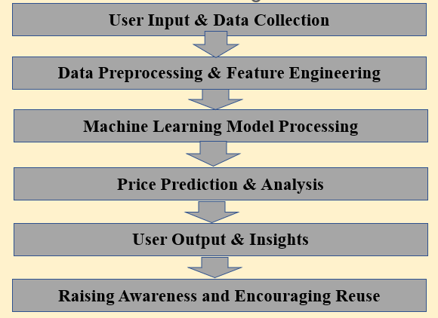

**Figure 3 : Work Flow Diagram**

**4.2 Use Case Diagram**

A **Use Case Diagram** is a graphical representation of the interactions between users (actors) and a system. It is part of **Unified Modeling Language (UML)** and is used to describe the functional requirements of a system. The diagram helps developers, designers, and stakeholders understand how different users interact with the system and what functionalities are available.

In the case of **CarCortex**, the **primary actor** is the **User (Car Owner)**, who interacts with the system to get an estimated resale value for their vehicle. Other possible actors may include **Dealerships, Admins, and External Data Providers**. The system itself consists of various **use cases**, such as **Input Vehicle Details, Data Validation, Fetch Market Data, Price Estimation, and Display Results**. Each use case represents a specific function that the system performs in response to user interactions.

The **relationships** between actors and use cases are depicted using **associations (lines)**, showing which users perform which actions. Additional relationships like **"Include"** (indicating a mandatory sub-function) and **"Extend"** (representing optional behaviors) can be used to refine the diagram further.

By analyzing the **Use Case Diagram**, developers can identify user requirements, refine system functionalities, and ensure smooth interactions between different components. It serves as a crucial blueprint in system design, helping to build an intuitive and efficient platform like CarCortex.

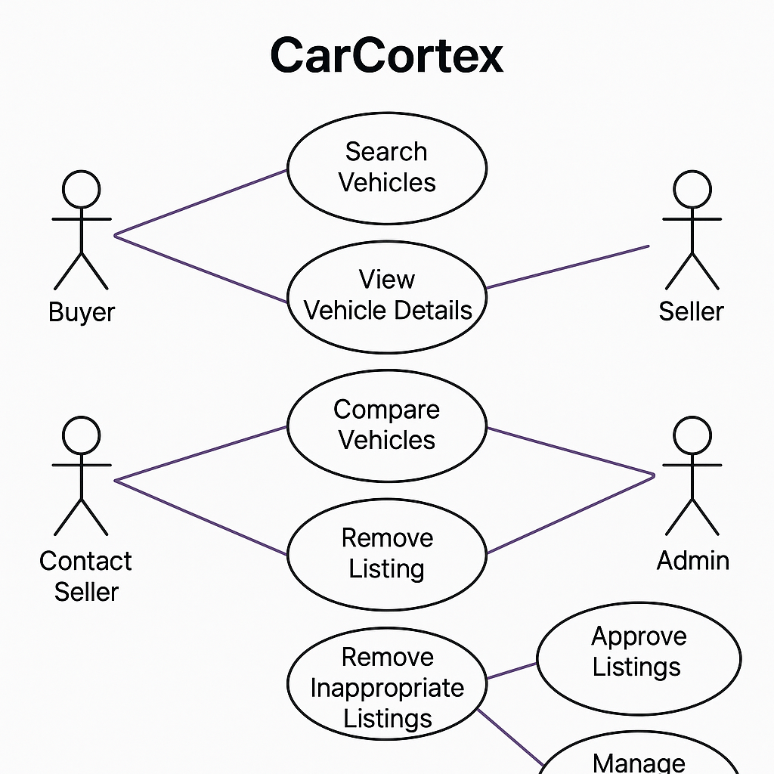

**Figure 4 ; Use Case Diagram**

**4.3 ER Diagram**

An **Entity-Relationship (ER) Diagram** is a conceptual model used to represent the structure of a database by defining how different data entities are related to each other. It provides a clear visual representation of the system’s data flow, helping database designers structure information efficiently. The ER diagram consists of **entities**, which are objects or concepts that store data, **attributes**, which define properties of entities, and **relationships**, which illustrate connections between entities. In **CarCortex**, entities such as **Users, Vehicles, Market Data, Price Estimations, and Transactions** play a crucial role in organizing system data. Each entity has unique **attributes**, such as a **Vehicle** having attributes like **Make, Model, Year, Mileage, and Condition**, while a **User** may have attributes like **User ID, Name, and Contact Information**. Relationships, represented by diamonds in the diagram, define how these entities interact, such as a **User owning a Vehicle** or a **Vehicle having a Price Estimation**. Primary keys and foreign keys are used to uniquely identify records and establish relationships between different tables in the database. The ER diagram is essential for **CarCortex**, as it helps in designing an optimized and scalable database, ensuring data integrity, reducing redundancy, and facilitating smooth data retrieval. It serves as a foundational tool for structuring a well-organized and efficient database system.

**Figure 5 ; E R Diagram**

**DESIGN (OUTPUT)**

The **Design** of CarCortex refers to the final visual and functional representation of the system based on its requirements and design specifications. It includes various UI components, database structures, and system interactions that ensure a seamless user experience.

1. **User Interface (UI) Design:**
   * A clean and modern **homepage** with a search bar for quick vehicle valuation.
   * A structured **login and registration page** for secure authentication.
   * A **dashboard** displaying estimated car prices, historical trends, and user activity.
   * Interactive forms for **inputting vehicle details** such as make, model, year, mileage, and condition.
   * A **result page** displaying the estimated resale price along with market analysis.
2. **Database Design:**
   * Well-structured **ER diagram** defining entities like **Users, Vehicles, Market Data, Price Estimations, and Transactions**.
   * **Relational database model** ensuring efficient storage and retrieval of vehicle pricing data.
   * Implementation of **primary keys, foreign keys, and indexing** for optimized performance.
3. **System Functionality & Processing:**
   * **Secure authentication system** using encrypted passwords and multi-factor authentication.
   * **Machine learning integration** for predictive vehicle price estimation based on market trends.
   * **API integration** with car marketplaces and dealerships for real-time data fetching.
   * **Automated report generation** providing users with insights on resale value trends.
4. **Technical Aspects:**
   * **Frontend development** using React.js for a dynamic and responsive interface.
   * **Backend development** with Node.js and Express.js for handling API requests.
   * **Database management** using MongoDB or PostgreSQL for structured data storage.
   * **Cloud hosting** to ensure scalability, high availability, and performance optimization.

The **design output** ensures that CarCortex provides an intuitive, efficient, and scalable platform for users to estimate their vehicle's resale price accurately. Let me know if you need a **visual representation** of any component!

**Screenshots:**

**CONCLUSION**

CarCortex is designed to be an innovative and user-friendly platform that enables vehicle owners to estimate the resale value of their cars accurately. By leveraging **advanced data analytics, market trends, and machine learning models**, the system provides reliable price estimations, helping users make informed selling decisions. The platform ensures smooth user experience through a **modern, responsive interface**, allowing seamless interaction across different devices. With a well-structured database and secure authentication mechanisms, users can confidently input their vehicle details and receive precise valuation insights.

The system is built with a robust **backend infrastructure**, integrating real-time market data and predictive analytics to enhance price accuracy. By using **cloud-based hosting and scalable architecture**, CarCortex ensures high availability and optimal performance. The inclusion of **API integrations** with car marketplaces and dealerships further enriches the pricing model by incorporating real-time vehicle listings and depreciation rates. This makes CarCortex a valuable tool for individuals looking to sell their vehicles at a competitive price.

Despite its advantages, the system faces challenges such as **data accuracy, dependency on market fluctuations, and competition from similar platforms**. However, continuous improvements in **data collection methods, machine learning algorithms, and user feedback mechanisms** can enhance its precision and reliability. Expanding the platform’s features, such as integrating AI-driven recommendations and real-time buyer connections, can further increase its usability and market reach.

In conclusion, CarCortex serves as a **comprehensive and intelligent car valuation platform** that empowers vehicle owners with valuable pricing insights. With its **technological foundation, user-centric design, and commitment to accuracy**, it stands as a promising solution for individuals looking to sell their cars efficiently. As the platform evolves, incorporating additional features and refining its pricing model will ensure that it remains a competitive and reliable tool in the automotive industry.

**BIBLIOGRAPHY**

* W3C. (n.d.). *Web Standards and Best Practices*. Retrieved from [www.w3.org](https://www.w3.org)
* Mozilla Developer Network (MDN). (n.d.). *HTML, CSS, and JavaScript for Responsive UI*. Retrieved from [developer.mozilla.org](https://developer.mozilla.org)
* React.js Documentation. (n.d.). *Building Scalable Web Applications*. Retrieved from [react.dev](https://react.dev)
* Kelley Blue Book (KBB). (n.d.). *How to Determine Your Car’s Value*. Retrieved from [www.kbb.com](https://www.kbb.com)
* Edmunds. (n.d.). *Vehicle Pricing and Market Trends*. Retrieved from [www.edmunds.com](https://www.edmunds.com)
* CarGurus. (n.d.). *Used Car Valuation and Pricing Trends*. Retrieved from [www.cargurus.com](https://www.cargurus.com)